From the Darkest Hours of 1948 until today, from West Point, Israel is not alone.
By Jerry Klinger

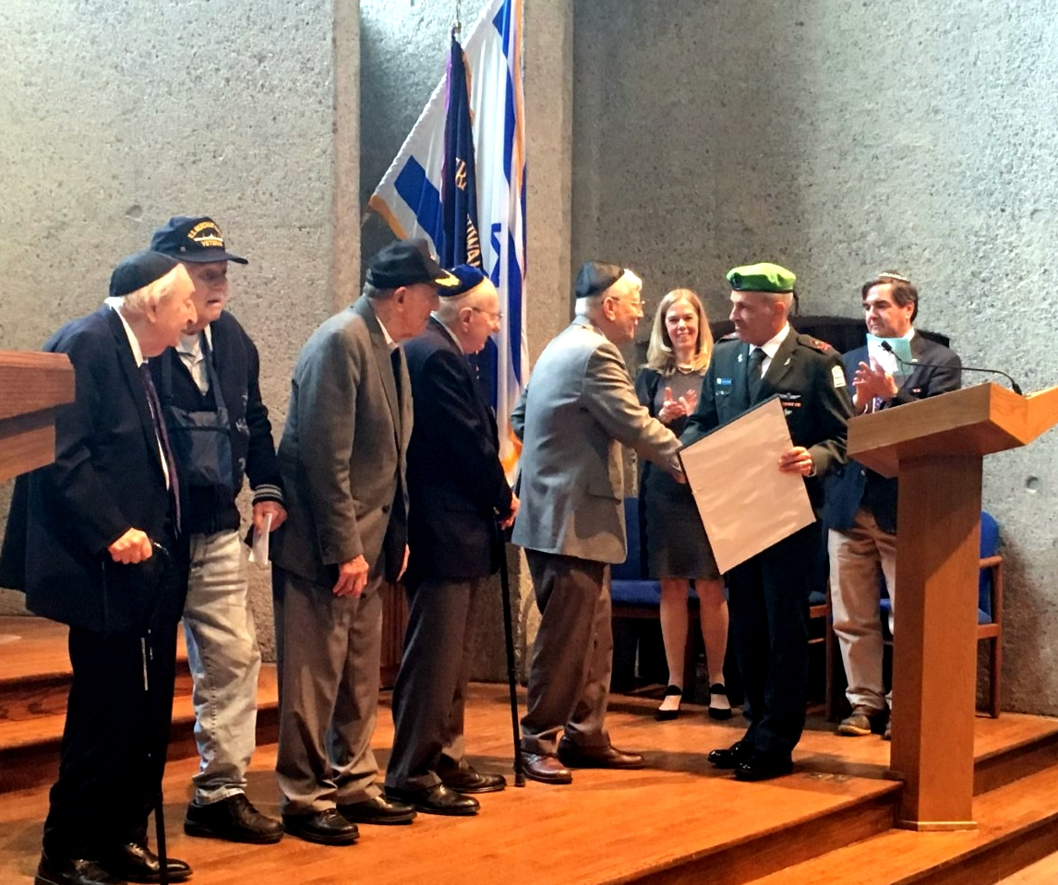
Presentation of the Machal Citation by Maj. Gen. Michael Edelstein IDF

1948, The military experts agreed, the young State of Israel would be dead the moment it was born. No cohesive military command, no air force, no armor, nothing. Yet, over 5,000 volunteers from around the world, Jews and including some Christians, came to fight for the impossible dream. They were called Machal – Volunteers from Outside of the Land. Israel was no longer completely alone.
The impossible dream became real. Little David defeated the promised horrors by the Arab Goliath.
Sunday, May 5, at the United States Military Academy, West Point, the veterans of that long-ago struggle were honored with a special recognition, the first ever Citation delivered by the Government of Israel to the American Veterans of Israel Legacy Corp. and Machal.
The Citation was presented by Major General Michael Edelstein, Israel Defense Attaché to the United States, to Ralph Lowenstein, Si Spiegelman, Paul Kaye, Harry Bieber, and David Sidorsky on behalf of AVILC and Machal.
Lowenstein was 18 and drove a half-track in the battle to liberate Jerusalem and returned to the U.S. to serve in Korea. Spiegelman, then 18, was an infantryman in the north of Israel and returned to the U.S. to serve in Korea. Kaye became one of Israel’s first elite Frogmen. Bieber was an infantryman and Sidorsky served in the Navy.
Opening remarks were delivered by Jeffrey Margolis, President of AVILC.
“Welcome, Ambassador Dayan, Deputy Consul General Nitzan, and Defense Attaché Aluf Edelstein, representing the Government of the State of Israel, and COL. Pawlikowski, Garrison Chaplain representing the United States Military Academy.

We thank the United States Military Academy and Rabbi David Ruderman, Captain, United States Army, for opening the Jewish Chapel to us, the American Veterans of Israel Legacy Corporation, for our 53rd annual Mickey Marcus Memorial Service…

We are very proud to announce that the Israel Defense Forces has formally acknowledged the service of the foreign volunteers of 1947-49, known as MACHAL, in helping to re-establish the Jewish State in the Land of Israel during the War of Independence. A citation signed by former Chief of the General Staff, Lieutenant General Gadi Eizenkot acknowledging that effort will be presented today, before you, to the volunteers present. We are also honored to have received a special letter from Prime Minister Benjamin Netanyahu regarding Mickey Marcus, the volunteers, and this Memorial.

We must give great thanks to Mr. Jerry Klinger, President of the Jewish American Society for Historic Preservation, and an AVILC board member for his vision, and the work that he did in Israel with both the Ministry of Defense and the office of the Prime Minister to bring about these meaningful recognitions.

I also want to thank the people who put this special memorial together. Si Spiegelman MACHAL, Donna Kantey Parker, daughter of two MACHAL volunteers who met in Israel during the War of Independence, and were married there, and, Rafi Marom, IDF combat veteran, Yom Kippur War.

Kol Ha Kavod!”

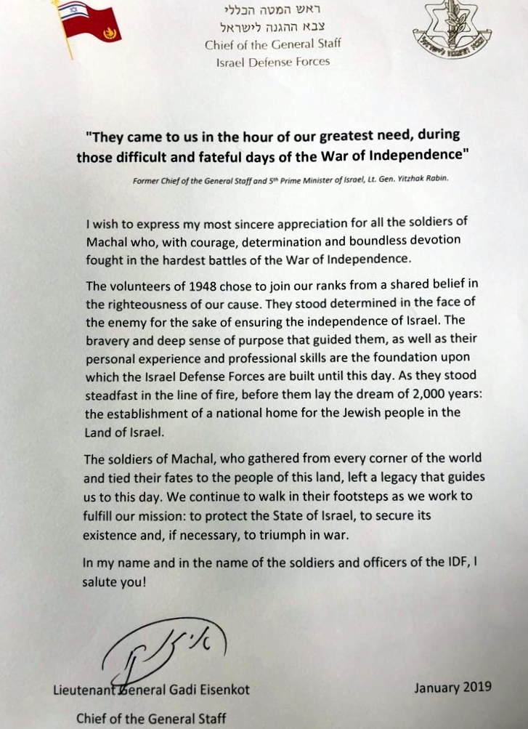

The Citation reads:

“They came to us in the hour of our greatest need, during those difficult and fateful days of the War of Independence.”

Former Chief of the General Staff and 5th Prime Minister of Israel, Lt. Gen. Yitzhak Rabin

I wish to express my most sincere appreciation for all the soldiers of Machal who, with courage, determination and boundless devotion fought in the hardest battles of the War of Independence.
The volunteers of 1948 chose to join our ranks from a shared belief in the righteousness of our cause. The stood determined in the face of the enemy for the sake of ensuring the independence of Israel. The bravery and deep sense of purpose that guided them, as well as their personal experience and professional skills are the foundation upon which the Israel Defense Forces are built until this day. As they stood steadfast in the line of fire, before them lay the dream of 2,000 years: the establishment of a national home for the Jewish people in the Land of Israel.
The soldiers of Machal, who gathered from every corner of the world and tied their fates to the people of this land, left a legacy that guides us to this day. We continue to walk in their footsteps as we work to fulfill our mission: to protect the State of Israel, to secure its existence and, if necessary, to triumph in war.

In my name and in the name of the soldiers and officers of the IDF, I salute you!

Lieutenant General Gadi Eisenkot
Chief of the General Staff

After the ceremony, everyone filed down to West Point’s Military Cemetery. A wreath was laid by the gravesite of Mickey Marcus. He was an American Military officer who became the first General of the Army of Israel in 2,000 years. He guided the War of Independence to Victory. Marcus was tragically killed near Abu Ghosh in the struggle for Jerusalem.

While the Citation was being presented missiles, flying metal of death, were being launched from Gaza to anywhere in Israel they could kill, indiscriminately. Israel’s military responded as it had in 1948.

Today, Israel, as in 1948 faced down the destruction of the State. The might of Israel, only partly unleased, responded.

Israel has new friends, unexpected friends who support Israel’s right to defend itself and protect its citizens. Unlike 1948, American volunteers can serve in the IDF without fear of losing their citizenship or returning to be imprisoned. An American President, the most supportive and friendly American President in history, sits in the White House, Donald Trump. Nations around the globe are changing their attitudes toward Israel because of American leadership. Incredibly, the European Union unanimously declared Israel has the right to defend itself. Even tweets were emerging from Saudi Arabia saying the same thing.

It is not that politics cannot change again and Israel may be alone. What was true in 1948 and is true today, Israel will not be alone. In Jewish hearts around the world and the hearts of many non-Jewish friends, Am Yisrael Chai rings forever.

